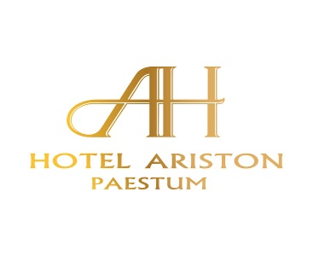

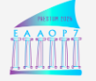

7TH INTERNATIONAL CONFERENCE EAAOP-7

On Environmental Application of Advanced Oxidation Processes

Paestum (Salerno), Italy June 10th – 13th 2025

PLEASE FILL THE FORM TO BOOK A ROOM

SURMANE …………………………..……………………….. NAME ……………………….…………….………….………………………

ARRIVAL DATE …………………………………………… DEPARTURE DATE …………………….……….…………………………….

NUMBER OF NIGHTS ……………………………………. MOBILE NUMBER ……….……………….…………………………………..

E-MAIL ……………………………………………………………………:::::.………………………………………………….……………….

INVOICE ON DEPARTURE TO BE ADDRESSED TO …………………::………. ……………… ………………….……………………

STREET……………………………………………….CITY ……………………………………………………ZIP CODE……………………..

………………………………………………………………………………………………………………..…………………………………………….

ROOM RESERVATION ON BED AND BREAKFAST BASIS

IN DOUBLE SINGLE USE ROOM EURO 100,00 PER NIGHT

IN DOUBLE/TWIN STANDARD ROOM EURO 140,00 PER NIGHT

IN DOUBLE SINGLE USE DELUXE ROOM EURO 200,00 PER NIGHT

IN DOUBLE / TWIN DE LUXE EURO 240,00 PER NIGHT

PLEASE ATTACH COPY OF PASSPORT OR IDENTITY CARD FOR A FAST CHECK IN

PLEASE WRITE NAME , SURNAME , DATE OF BIRTH AND PLACE OF BIRTH OF SECOND PERSON IN THE ROOM

………………………………………………………………………………………………………………………………………………………….

PLEASE NOTE IF THERE ARE ANY ALLERGIES …………………………………………………………………………………………….

TO CONFIRM THE RESERVATION WE REQUIRE DEPOSIT OF FIRST NIGHT STAY TO BE SENT TO:

UNICREDIT BANK – IBAN IT 23 H 02008 76021 000500090640 - SWIFT CODE UNCRITM 1644

ACCOUNT NUMBER OF : HOTEL ARISTON S.r.l.

OR WE WILL SEND YOU A LINK FOR THE PAYMENT ON YOUR E MAIL ……………………………………………………

………………………………………………………………………………………………………………………………………………………….

PLEASE SEND THIS FORM TO : [info@hotelariston.com](mailto:info@hotelariston.com) AND WE WILL CONFIRM YOUR RESERVATION

DATE SIGNATURE

……………………………… ………………………………

HOTEL ARISTON – VIA LAURA 13 – 84047 CAPACCIO PAESTUM ( SALERNO ) TEL. 0039 0828 851333